# **Linux Command Cheat Sheet**

**10, 2023**

**In this Linux/Unix command line cheat sheet, you will learn:**

* [**Basic Linux commands**](https://www.guru99.com/linux-commands-cheat-sheet.html#1)
* [**File Permission commands**](https://www.guru99.com/linux-commands-cheat-sheet.html#2)
* [**Environment Variables command**](https://www.guru99.com/linux-commands-cheat-sheet.html#3)
* [**User management commands of linux**](https://www.guru99.com/linux-commands-cheat-sheet.html#4)
* [**Networking command**](https://www.guru99.com/linux-commands-cheat-sheet.html#5)
* [**Process command**](https://www.guru99.com/linux-commands-cheat-sheet.html#6)
* [**VI Editing Commands**](https://www.guru99.com/linux-commands-cheat-sheet.html#7)

## Basic Linux commands

| **Command** | **Description** |  |
| --- | --- | --- |
| **ls** | **Lists all files and directories in the present working directory** |  |
| **ls -R** | **Lists files in sub-directories as well** |  |
| **ls -a** | **Lists hidden files as well** |  |
| **ls -al** | **Lists files and directories with detailed information like permissions, size, owner, etc.** |  |
| **cd or cd ~** | **Navigate to HOME directory** |  |
| **cd ..** | **Move one level up** |  |
| **cd** | **To change to a particular directory** |  |
| **cd /** | **Move to the root directory** |  |
| **cat > filename** | **Creates a new file** |  |
| **cat filename** | **Displays the file content** |  |
| **cat file1 file2 > file3** | **Joins two files (file1, file2) and stores the output in a new file (file3)** |  |
| **mv file "new file path"** | **Moves the files to the new location** |  |
| **mv filename new_file_name** | **Renames the file to a new filename** |  |
| **sudo** | **Allows regular users to run programs with the security privileges of the superuser or root** |  |
| cp --help |  |  |
| **cp** | **Copy folder** |  |
| **pwd** | **present working directory** |  |
| **view** |  |  |
| **find**  **find -iname** word  **find -iname** word-type f  **find . -name “*.gz”** | **search** |  |
| **etc** |  |  |
| **diff** |  |  |
| **.** | **Current location** |  |
| **grep**  **sudo apt install grap** | **useful command to search for matching patterns in a file.** |  |
| **rm filename/\*** | **Deletes a**ll **file** |  |
| **rm filename** | **Deletes a file** |  |
| **man** | **Gives help information on a command** |  |
| **history** | **Gives a list of all past commands typed in the current terminal session** |  |
| **clear** | **Clears the terminal** |  |
| **mkdir directoryname** | **Creates a new directory in the present working directory or a at the specified path** |  |
| **mkdir -p directoryname** | **Creates a new directory , Overwrite or create hierarchy in the present working directory or a at the specified path** |  |
| **rmdir** | **Deletes a directory** |  |
| **du -hs /path/to/directory**  du -h | sort -h  du -hsc * | **Total size folder** |  |
| **tree --du -h /path/to/directory**  sudo apt-get install tree | **Total size folder tree** |  |
| **mv** | **Renames a directory** |  |
| **pr -x** | **Divides the file into x columns** |  |
| **pr -h** | **Assigns a header to the file** |  |
| **pr -n** | **Denotes the file with Line Numbers** |  |
| **lp -nc , lpr c** | **Prints “c” copies of the File** |  |
| **lp-d lp-P** | **Specifies name of the printer** |  |
| **apt-get** | **Command used to install and update packages** |  |
| **mail -s 'subject' -c 'cc-address' -b 'bcc-address' 'to-address'** | **Command to send email** |  |
| **mail -s "Subject" to-address < Filename** | **Command to send email with attachment** |  |

## File Permission commands

| **Command** | **Description** |  |
| --- | --- | --- |
| **ls** | **to show file** |  |
| **Ls -ltr** | **to show file type and access permission** |  |
| **r** | **read permission** |  |
| **w** | **write permission** |  |
| **x** | **execute permission** |  |
| **-=** | **no permission** |  |
| **Chown user** | **For changing the ownership of a file/directory** |  |
| **Chown user:group filename** | **change the user as well as group for a file or directory** |  |

## Environment Variables command

| **Command** | **Description** |  |
| --- | --- | --- |
| **echo $VARIABLE** | **To display value of a variable** |  |
| **env** | **Displays all environment variables** |  |
| **VARIABLE_NAME= variable_value** | **Create a new variable** |  |
| **Unset** | **Remove a variable** |  |
| **export Variable=value** | **To set value of an environment variable** |  |

## User management commands of linux

| **Command** | **Description** |  |
| --- | --- | --- |
| **sudo adduser username** | **To add a new user** |  |
| **sudo passwd -l 'username'** | **To change the password of a user** |  |
| **sudo userdel -r 'username'** | **To remove a newly created user** |  |
| **sudo usermod -a -G GROUPNAME USERNAME** | **To add a user to a group** |  |
| **sudo deluser USER GROUPNAME** | **To remove a user from a group** |  |
| **finger** | **Shows information of all the users logged in** |  |
| **finger username** | **Gives information of a particular user** |  |

**AD**

## Networking command

| **Command** | **Description** |  |
| --- | --- | --- |
| **SSH username@ip-address or hostname** | **login into a remote Linux machine using SSH** |  |
| **Ping hostname="" or =""** | **To ping and Analyzing network and host connections** |  |
| **dir** | **Display files in the current directory of a remote computer** |  |
| **cd "dirname"** | **change directory to “dirname” on a remote computer** |  |
| **put file** | **upload ‘file’ from local to remote computer** |  |
| **get colne url** | **Download ‘file’ from g**it **to local computer** |  |
| **get file** | **Download ‘file’ from remote to local computer** |  |
| **quit** | **Logout** |  |

## Process command

| **Command** | **Description** |  |
| --- | --- | --- |
| **bg** | **To send a process to the background** |  |
| **fg** | **To run a stopped process in the foreground** |  |
| **top** | **Details on all Active Processes** |  |
| **ps** | **Give the status of processes running for a user** |  |
| **ps PID** | **Gives the status of a particular process** |  |
| **pidof** | **Gives the Process ID (PID) of a process** |  |
| **kill PID** | **Kills a process** |  |
| **nice** | **Starts a process with a given priority** |  |
| **renice** | **Changes priority of an already running process** |  |
| **df** | **Gives free hard disk space on your system** |  |
| **free** | **Gives free RAM on your system** |  |

**AD**

## VI Editing Commands

| **Command** | **Description** |  |
| --- | --- | --- |
| **i** | **Insert at cursor (goes into insert mode)** |  |
| **a** | **Write after cursor (goes into insert mode)** |  |
| **A** | **Write at the end of line (goes into insert mode)** |  |
| **ESC** | **Terminate insert mode** |  |
| **u** | **Undo last change** |  |
| **U** | **Undo all changes to the entire line** |  |
| **o** | **Open a new line (goes into insert mode)** |  |
| **dd** | **Delete line** |  |
| **3dd** | **Delete 3 lines** |  |
| **D** | **Delete contents of line after the cursor** |  |
| **C** | **Delete contents of a line after the cursor and insert new text. Press ESC key to end insertion.** |  |
| **dw** | **Delete word** |  |
| **4dw** | **Delete 4 words** |  |
| **cw** | **Change word** |  |
| **x** | **Delete character at the cursor** |  |
| **r** | **Replace character** |  |
| **R** | **Overwrite characters from cursor onward** |  |
| **s** | **Substitute one character under cursor continue to insert** |  |
| **S** | **Substitute entire line and begin to insert at the beginning of the line** |  |
| **~** | **Change case of individual character** |  |

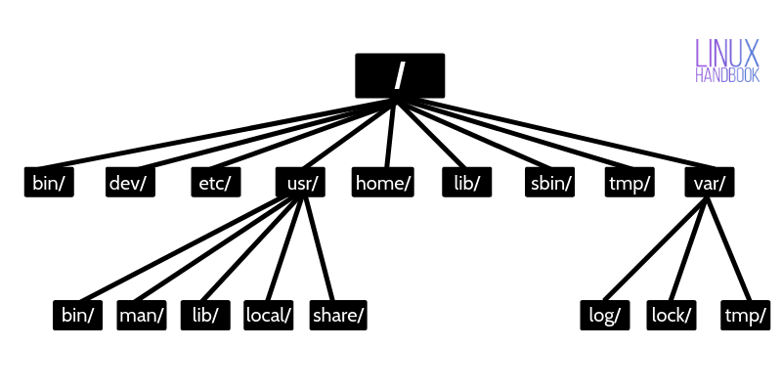

**/bin – Binaries**

The ‘/bin’ directly contains the executable files of many basic shell commands like ls, [cp](https://linuxhandbook.com/copy-directory-linux/), [cd](https://linuxhandbook.com/cd-command-examples/) etc. Mostly the programs are in binary format here and accessible by [all the users in the Linux system](https://linuxhandbook.com/linux-list-users/).

**/dev – Device files**

This directory only contains special files, including those relating to the devices. These are virtual files, not physically on the disk.

Some interesting examples of these files are:

* [/dev/null](https://linuxhandbook.com/redirect-dev-null/): can be sent to destroy any file or string
* /dev/zero: contains an infinite sequence of 0
* /dev/random: contains an infinite sequence of random values

**/etc – Configuration files**

The /etc directory contains the core configuration files of the system, use primarily by the administrator and services, such as the password file and networking files.

If you need to make changes in system configuration (for example, changing the hostname), this is where you’ll find the respective files.

**/usr – User binaries and program data**

in ‘/usr’ go all the executable files, libraries, source of most of the system programs. For this reason, most of the files contained therein is read­only (for the normal user)

* ‘/usr/bin’ contains basic user commands
* ‘/usr/sbin’ contains additional commands for the administrator
* ‘/usr/lib’ contains the system libraries
* ‘/usr/share’ contains documentation or common to all libraries, for example ‘/usr/share/man’ contains the text of the manpage

**/home – User personal data**

Home directory contains personal directories for the users. The home directory contains the user data and user-specific configuration files. As a user, you’ll put your personal files, notes, programs etc in your home directory.

When you [create a user on your Linux system](https://linuxhandbook.com/useradd-vs-adduser/), it’s a general practice to create a home directory for the user. Suppose your Linux system has two users, Alice and Bob. They’ll have a home directory of their own at locations /home/alice and /home/bob.

Do note that Bob won’t have access to /home/alice and vice versa. That makes sense because only the user should have access to his/her home. You may read about [file permissions in Linux](https://linuxhandbook.com/linux-file-permissions/) to know more on this topic.

**/lib – Shared libraries**

Libraries are basically codes that can be used by the executable binaries. The /lib directory holds the libraries needed by the binaries in /bin and /sbin directories.

Libraries needed by the binaries in the /usr/bin and /usr/sbin are located in the directory /usr/lib.

**/sbin – System binaries**

This is similar to the /bin directory. The only difference is that is contains the binaries that can only be run by root or a sudo user. You can think of the ‘s’ in ‘sbin’ as super or sudo.

**/tmp – Temporary files**

As the name suggests, this directory holds temporary files. Many applications use this directory to store temporary files. Even you can use directory to store temporary files.

But do note that the contains of the /tmp directories are deleted when your system restarts. Some Linux system also delete files old files automatically so don’ store anything important here.

**/var – Variable data files**

Var, short for variable, is where programs store runtime information like system logging, user tracking, caches, and other files that system programs create and manage.

The files stored here are NOT cleaned automatically and hence it provides a good place for system administrators to look for information about their system behavior. For example, if [you want to check the login history in your Linux system](https://linuxhandbook.com/linux-login-history/), just check the content of the file in /var/log/wtmp.

**/boot – Boot files**

The ‘/boot’ directory contains the files of the kernel and boot image, in addition to LILO and Grub. It is often advisable that the directory resides in a partition at the beginning of the disc.

**/proc – Process and kernel files**

The ‘/proc’ directory contains the information about currently running processes and kernel parameters. The content of the proc directory is used by a number of tools to get runtime system information.

For example, if you want to [check processor information in Linux](https://linuxhandbook.com/check-cpu-info-linux/), you can simply refer to the file /proc/cpuinfo. You want to [check memory usage of your Linux system](https://linuxhandbook.com/linux-memory-usage/), just look at the content of /proc/meminfo file.

**/opt – Optional software**

Traditionally, the /opt directory is used for installing/storing the files of third-party applications that are not available from the distribution’s repository.

The normal practice is to keep the software code in opt and then link the binary file in the /bin directory so that all the users can run it.

**/root – The home directory of the root**

There is /root directory as well and it works as the home directory of the root user. So instead of /home/root, the home of root is located at /root. Do not confuse it with the root directory (/).

**/media – Mount point for removable media**

When you connect a removable media such as USB disk, SD card or DVD, a directory is automatically created under the /media directory for them. You can access the content of the removable media from this directory.

**/mnt – Mount directory**

This is similar to the /media directory but instead of automatically mounting the removable media, mnt is used by system administrators to manually mount a filesystem.

**/srv – Service data**

The /srv directory contains data for services provided by the system. For example, if you run a HTTP server, it’s a good practice to store the website data in the /srv directory.

I think this much information is enough for you to understand the Linux directory structure and its usage.

In the end, if you want, you can download and save this image for quick reference to the directory structure in Linux systems.

[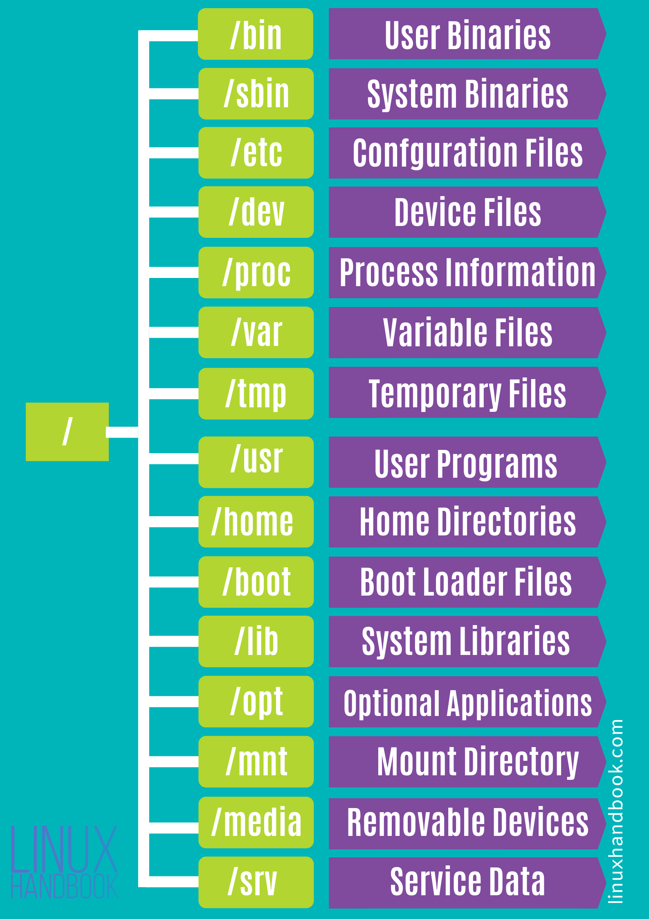](https://linuxhandbook.com/content/images/2020/06/linux-system-directoies-poster.png)

**#!/bin/sh**

**# Usage: backup FILE...**

**# Create a GNU-style backup of each listed FILE.**

**fail=0**

**for i; do**

**cp --backup --force --preserve=all -- "$i" "$i" || fail=1**

**done**

**exit $fail**